**Topics:** CodeCommit, CodePipeline, CodeBuild, CodeDeploy

**AWS CI/CD:**

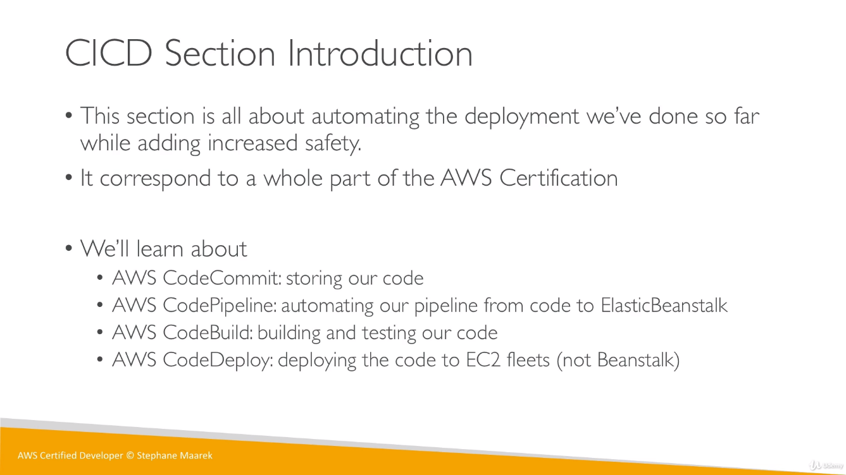

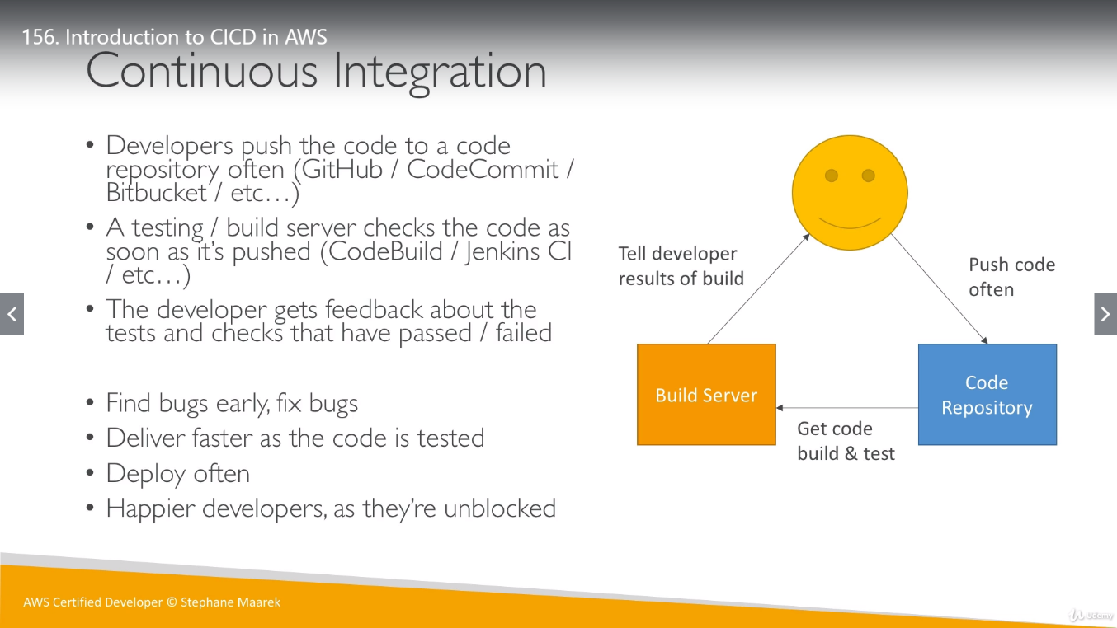

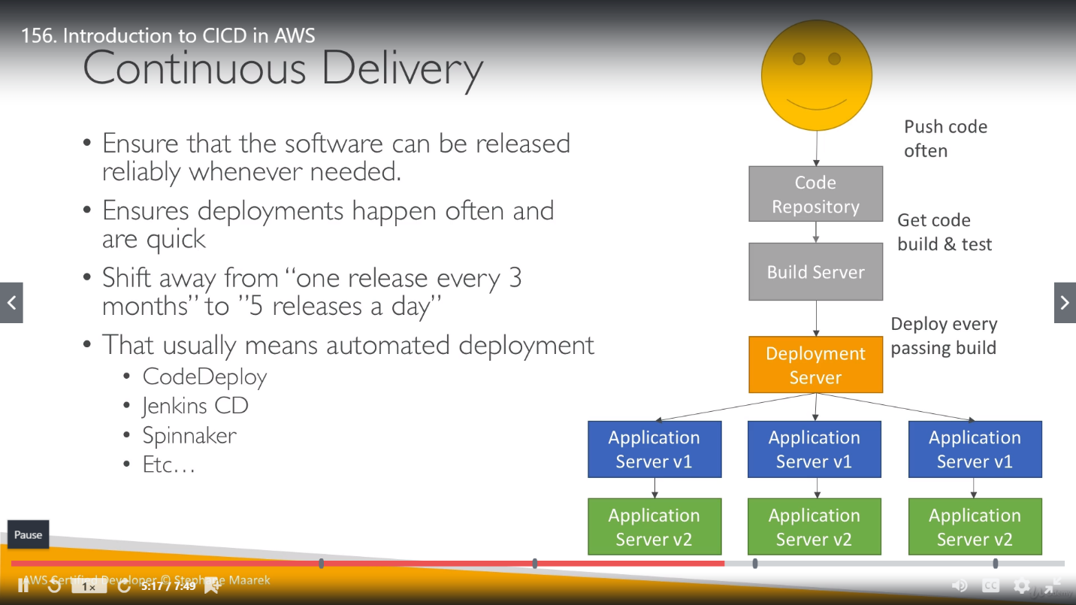

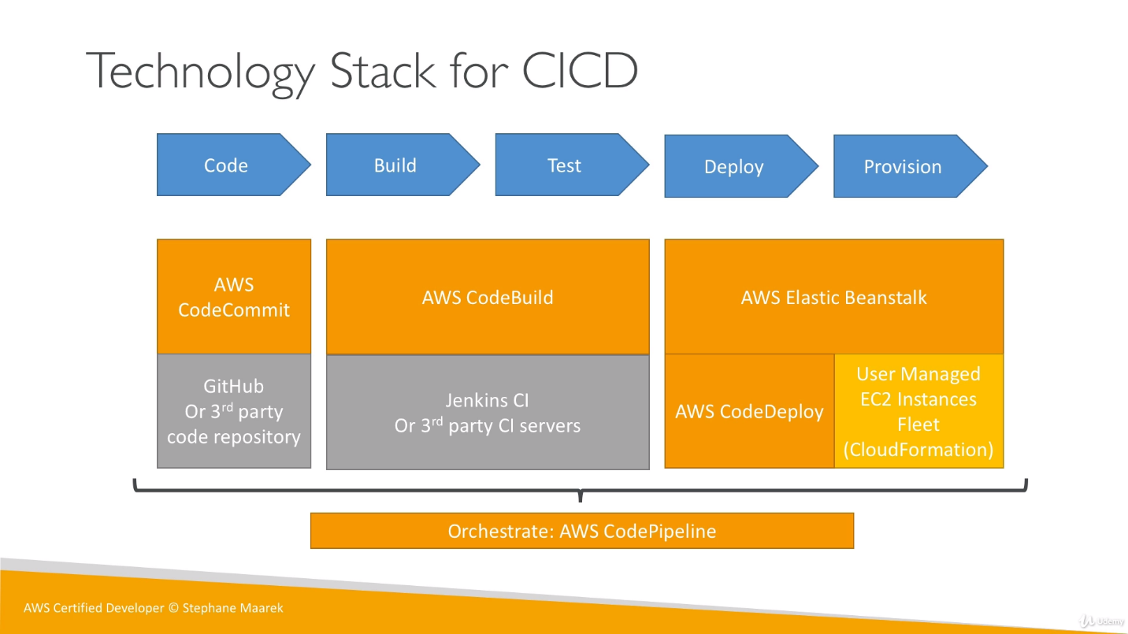

* **Code:** version control tool using AWS CodeCommit / (non AWS) GitHub
* **Build & Test:** AWS CodeBuild / (non AWS) Jenkin CI pipeline
* **Deploy:** AWS Elastic Beanstalk or (AWS CodeDeploy + EC2 instance fleet using CloudFormation) / (non AWS) Jenkin CD pipeline

**CodeCommit:** Private GIT repository managed by AWS

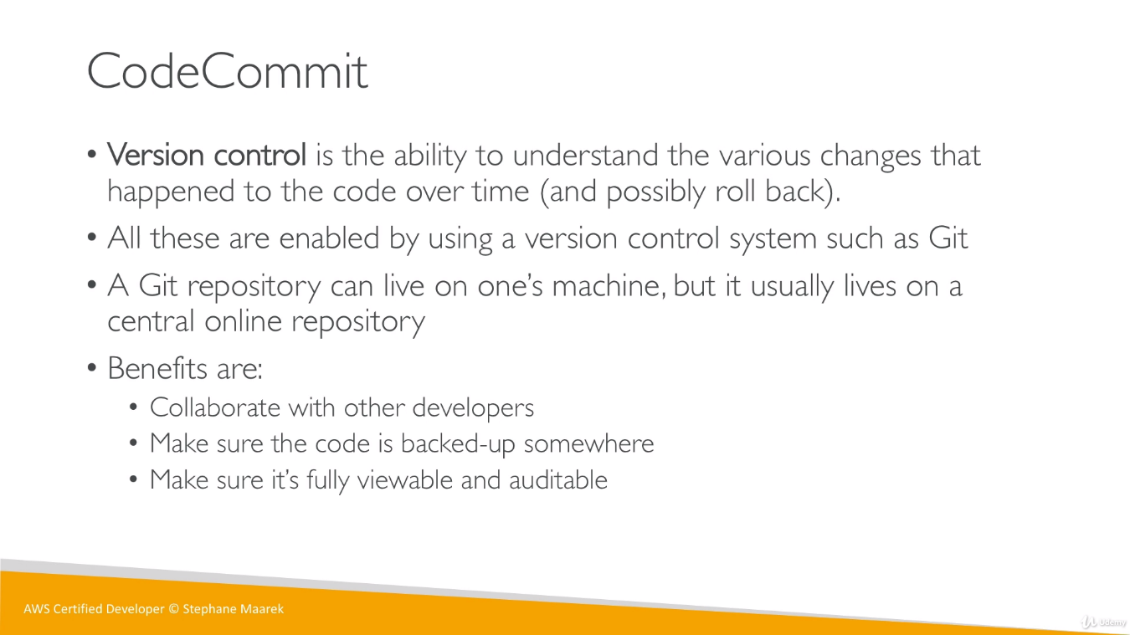

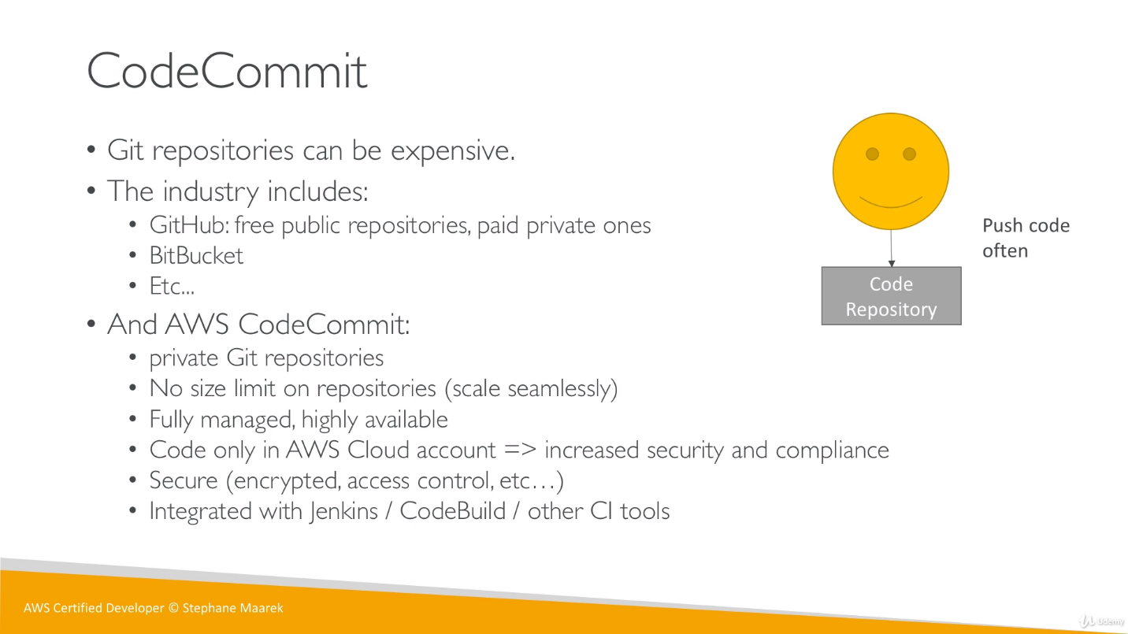

**Qn:** How to give access of my code from our CodeCommit account to another account?

**Ans:** Create an IAM role in our account using AWS STS (with **AssumeRole** API, it’s a cross account role).

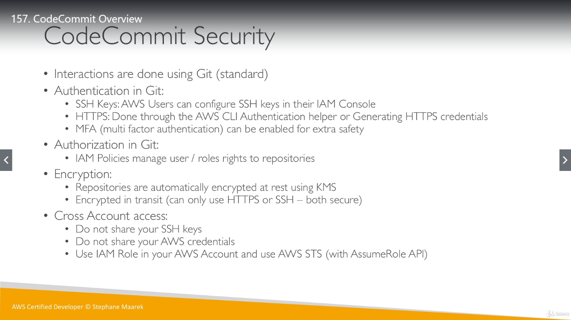

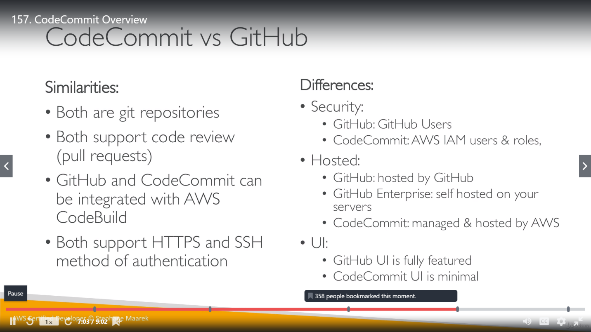

We can notify user either using notification service or Trigger service. Events are created for Notification using notification rule and Triggers create separately. We can create up to 10

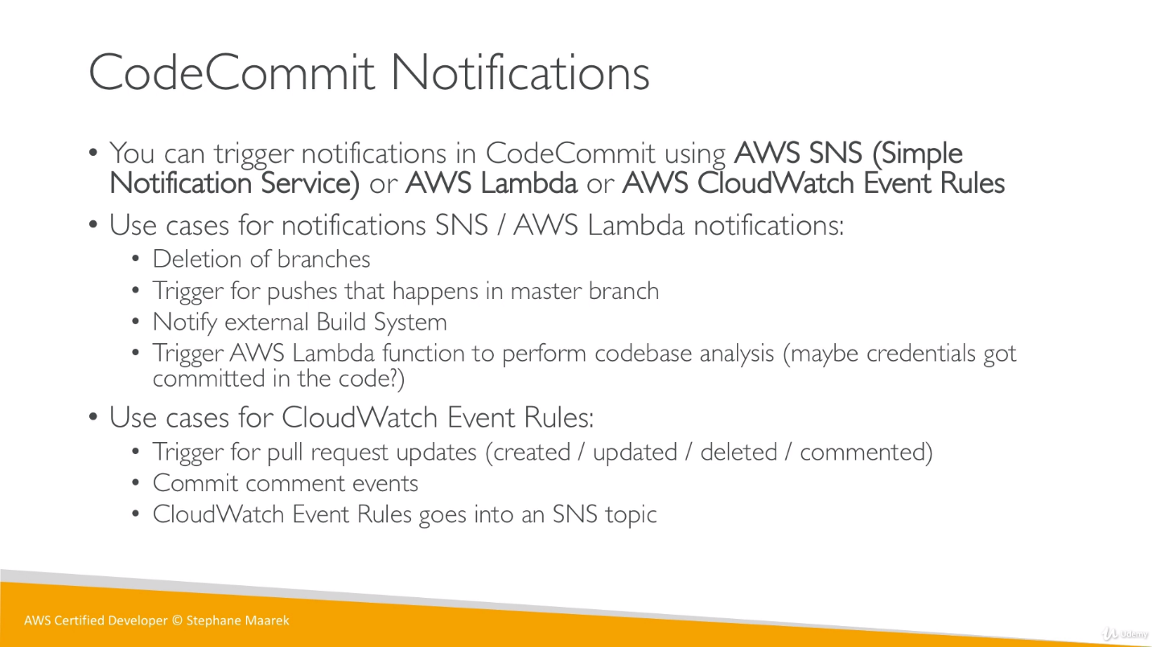

There are 3 ways to notify to user for any changes in CodeCommit, but not a single one is able to deliver all features alone.

**imp** Notifications and Triggers are created separately. Triggers are more related to branch like push to a branch. Create a new branch and delete existing branch.

**Simple Notification Service or AWS Lambda**: Notifications about deletion of a branch, trigger push on master, build, trigger lambda to perform codebase analysis.

**CloudWatch Event Rules:** Notifications about pull request (anything happen around pull request like create, delete, update, commented the pull request), when reviewer comments on our pull request (to merge feature code in master) and all these notification from CloudWatch goes into SNS.

* If we connect using rote account then we don’t need SSH into CodeCommit repository but if we logged in using IAM user then we will get all 3 options for connection through HTTP, HTTPS(GRC) and SSH.

**Notification example:**

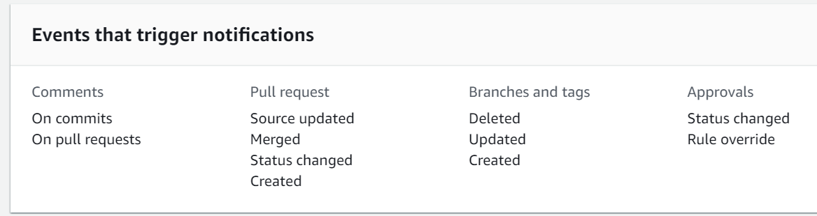

**Trigger Example:**

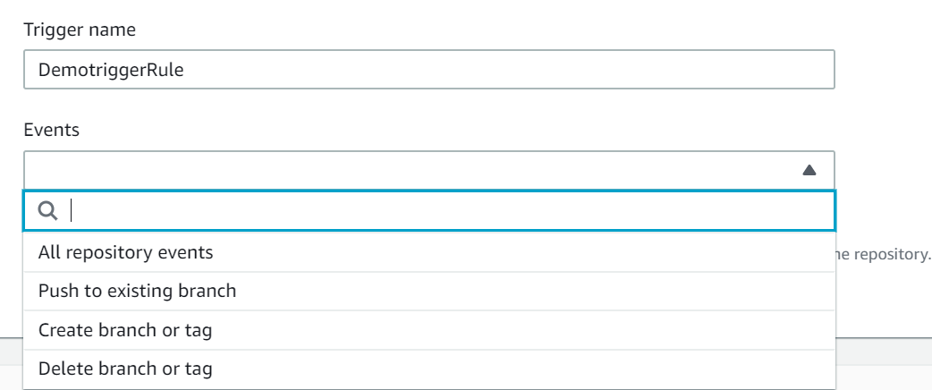

Branch Creation and Branch Deleting in already been covered in notifications so there is no significance for those triggers so we can choose “Push to existing Branch” as a trigger.

* To access this code from CodeCommit repo, we can either use HTTPS or SSH way similar to GIT. To use this, we have to configure **Security credentials** under user “AshvaniV1” accordingly.

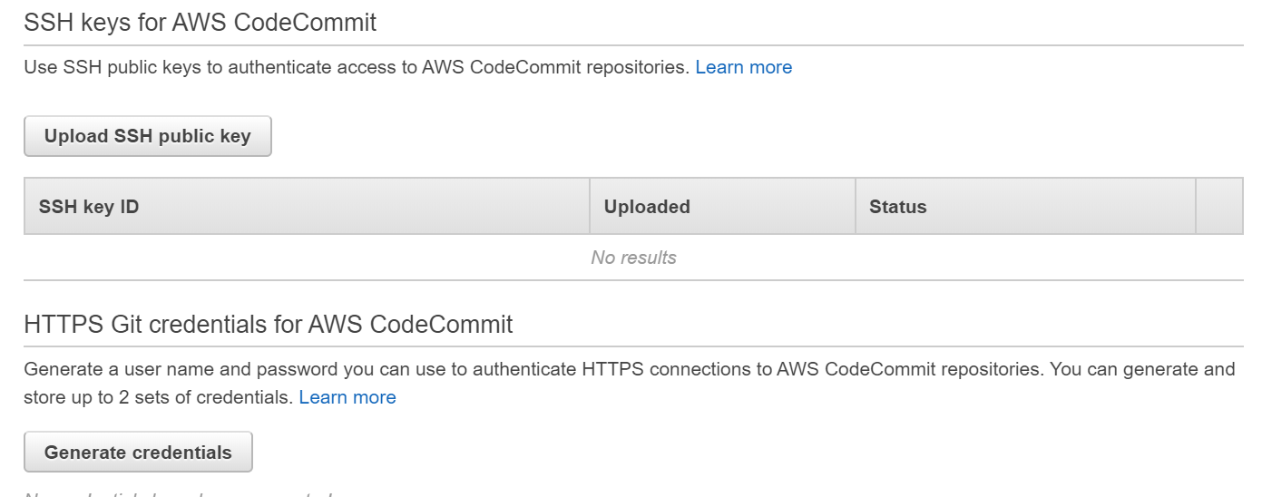

We can generate user name and password from here for HTTPS and later use these credentials in GIT to clone the code from CodeCommit.

**AWS CodePipeline Artifacts:**

**Artifacts:** A file or group of files

Pipeline artifacts provide a way to share files between stages in a pipeline or between different pipelines. They are typically the output of a build process that needs to be consumed by another job or be deployed.

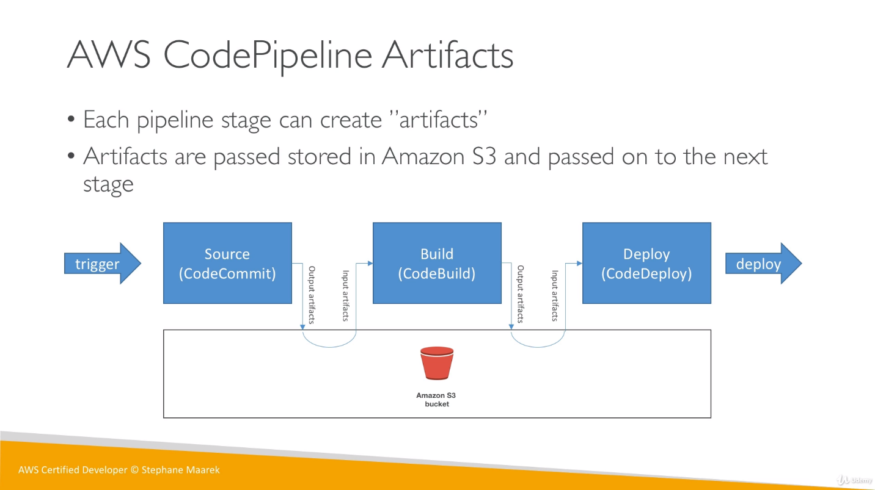

**Pipeline troubleshooting:** We can use AWS CloudWatch events and AWS CloudTrail for pipeline troubleshooting.

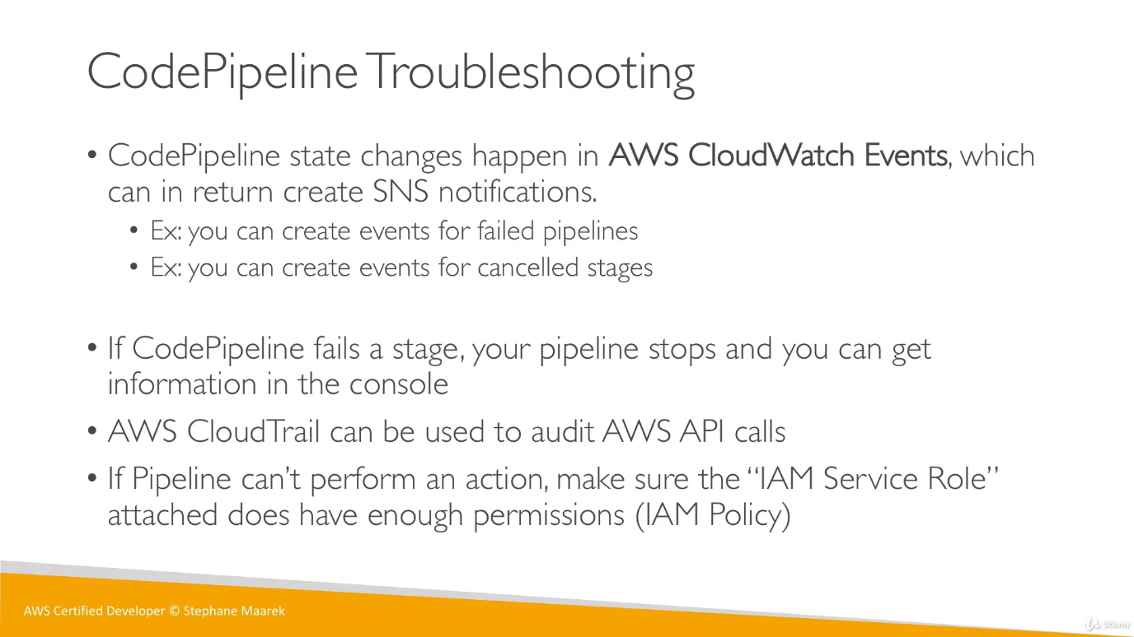

Once we start with pipeline, we just link Sources, Build and Deploy stages. It required an IAM role attached to it so we can create it once creating the pipeline or can use already created role.

We have an option to provide the source stage mean from where we want to take the code for pipeline. We are choosing CodeCommit here and then choose repository name for this CodeCommit.

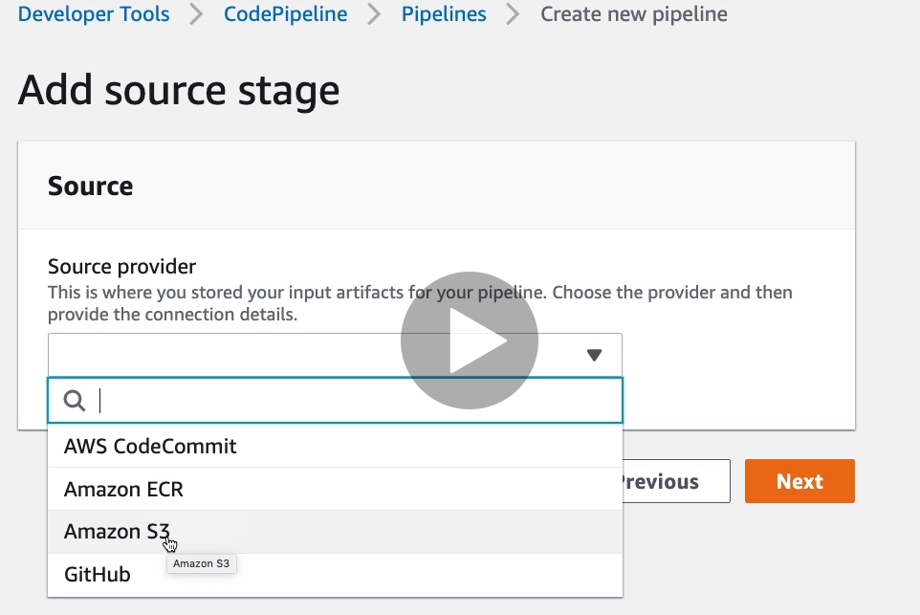

Pipeline can start automatically whenever any changes occur in repository. We have 2 options here to choose between to make this configuration.

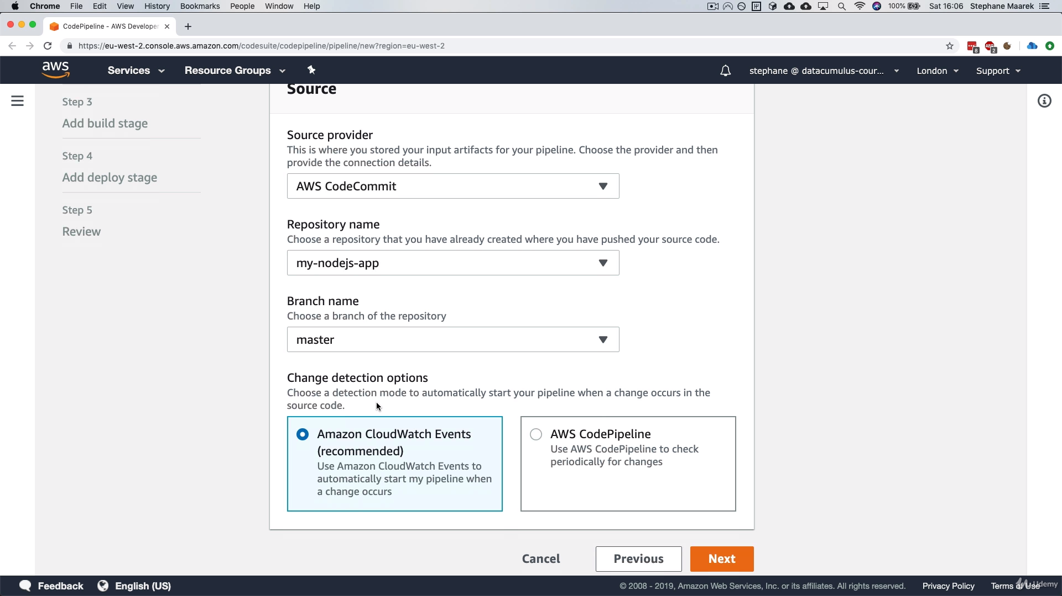

Build (CodeBuild/Jenkin) is an optional step in pipeline creation.

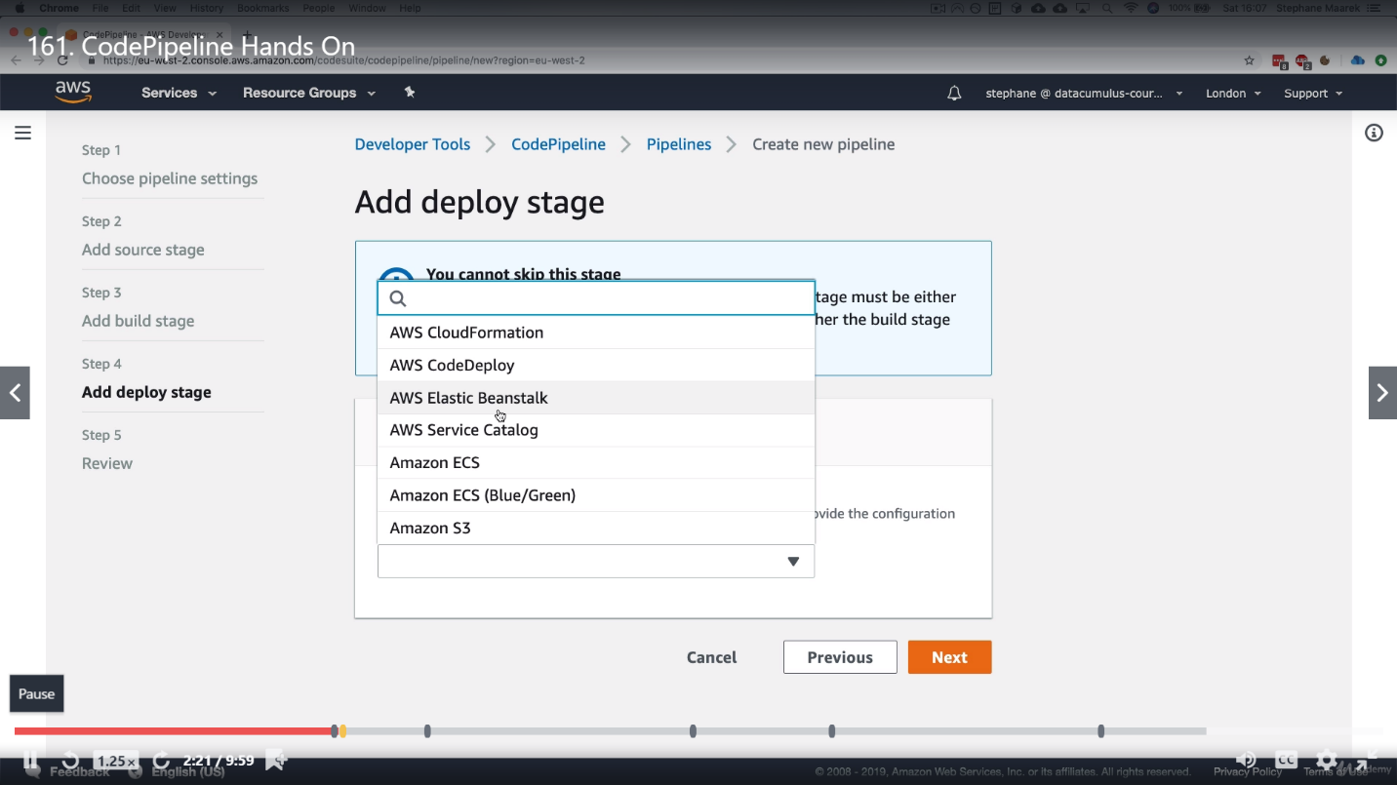

We have these many options from AWS pipeline to deploy our code into above mentioned services. We will choose Elastic Beanstalk here for learning purpose.

It will show Beanstalk name and environment name from Beanstalk application that we had created earlier.

So, this pipeline is taking code from CodeCommit, not doing any build and deploying the code into Beanstalk.

Once we created a pipeline, it can be modified, and we can add more stages. Whenever we add a new stage to a pipeline, we have to add an action stage on this. **imp** one stage can have multiple action groups.

We can choose different-different environments from an application under single pipeline.

If we have multiple action groups, we can have one action for each group, and they will run sequentially but we can also have multiple actions under single action groups so these actions will run in parallel.

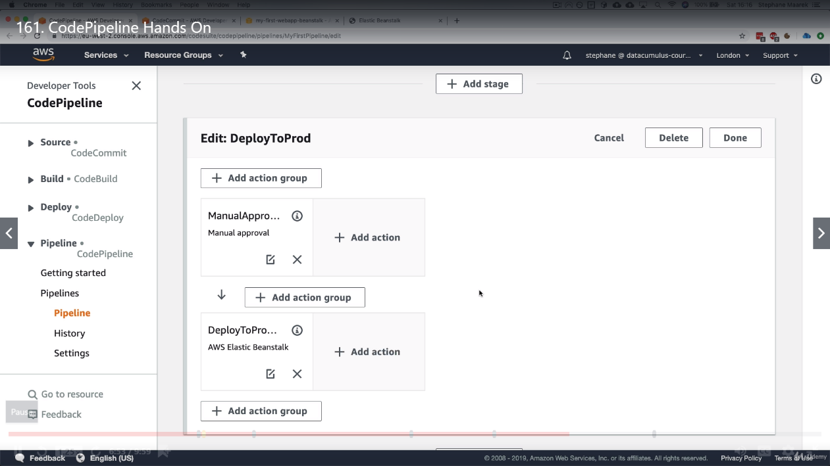

**CodeBuild:**

AWS CodeBuild is a fully managed continuous integration service that compiles source code, runs tests, and produces software packages that are ready to deploy.

With CodeBuild, we don’t need to provision, manage, and scale our own build servers.

CodeBuild scales continuously and process multiple builds concurrently, so our builds are not left waiting in a queue.

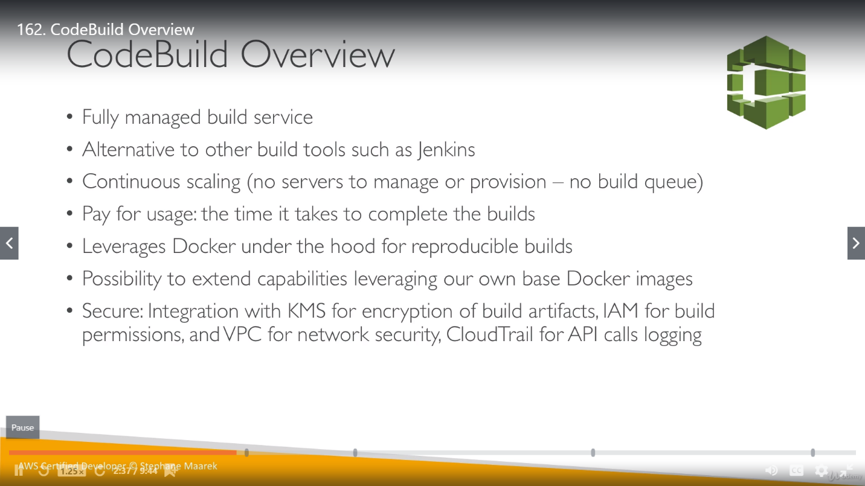

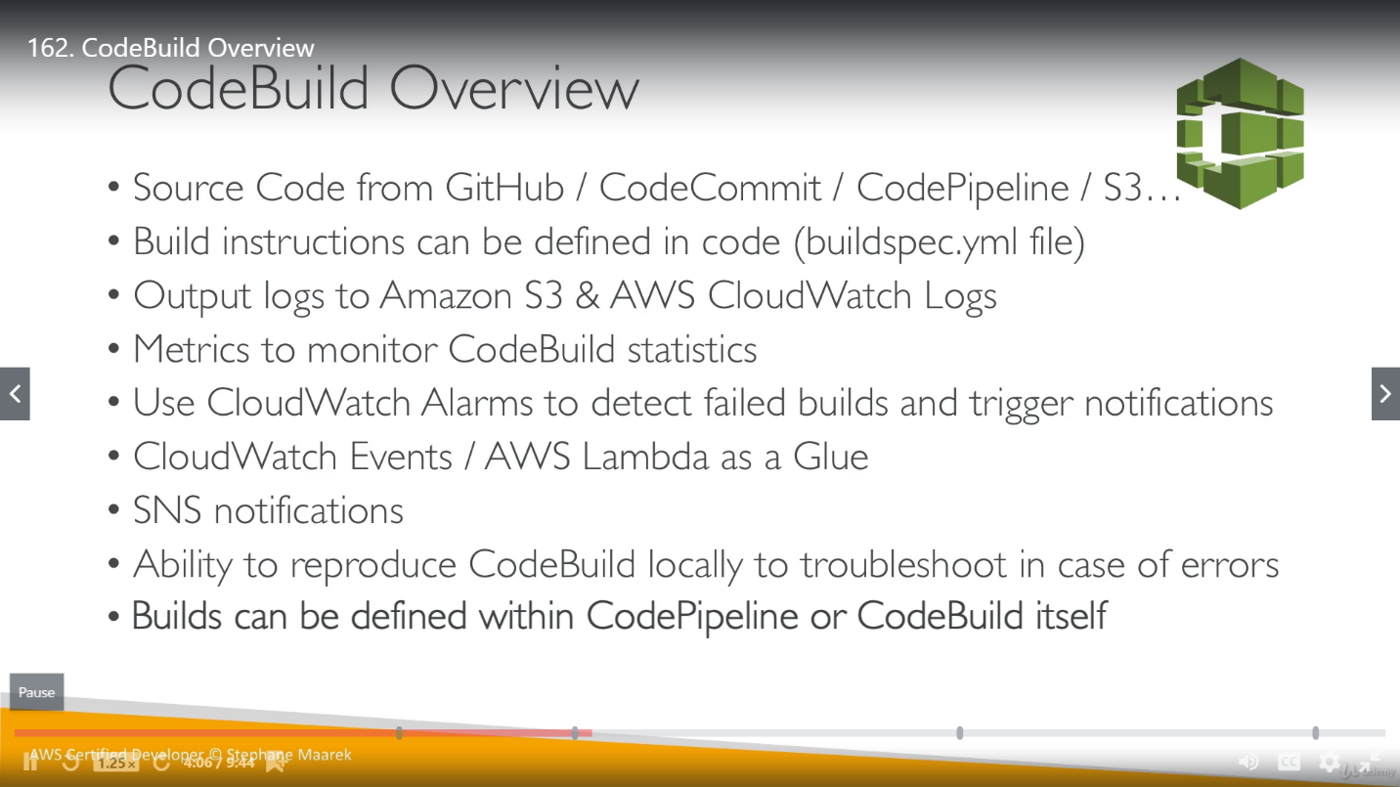

Build instruction is defined in a yaml file named as **buildspec.yml** . this file should be in root directory, not in any sub directory.

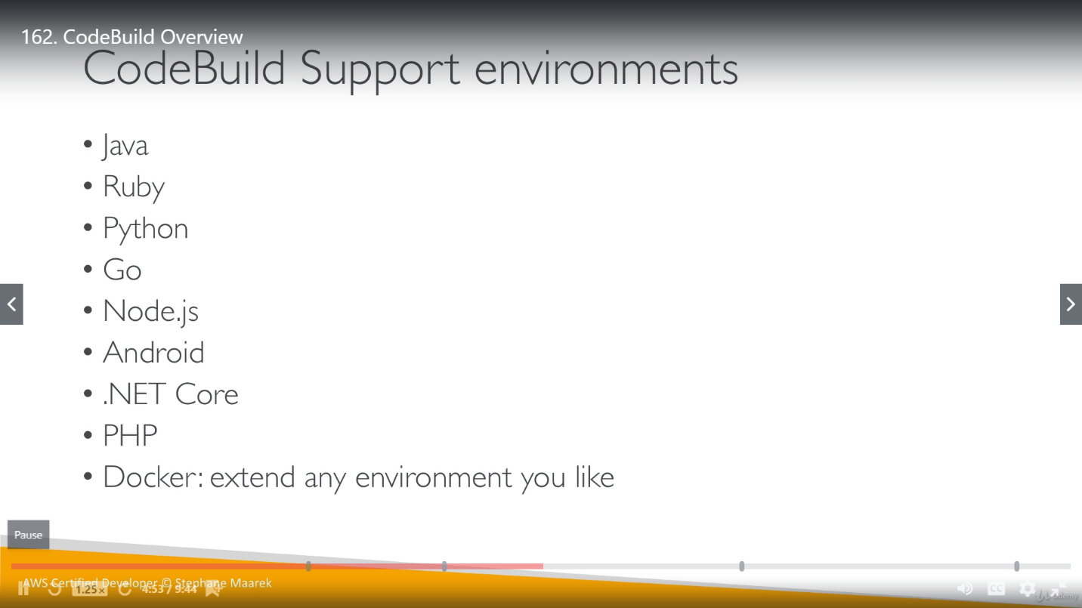

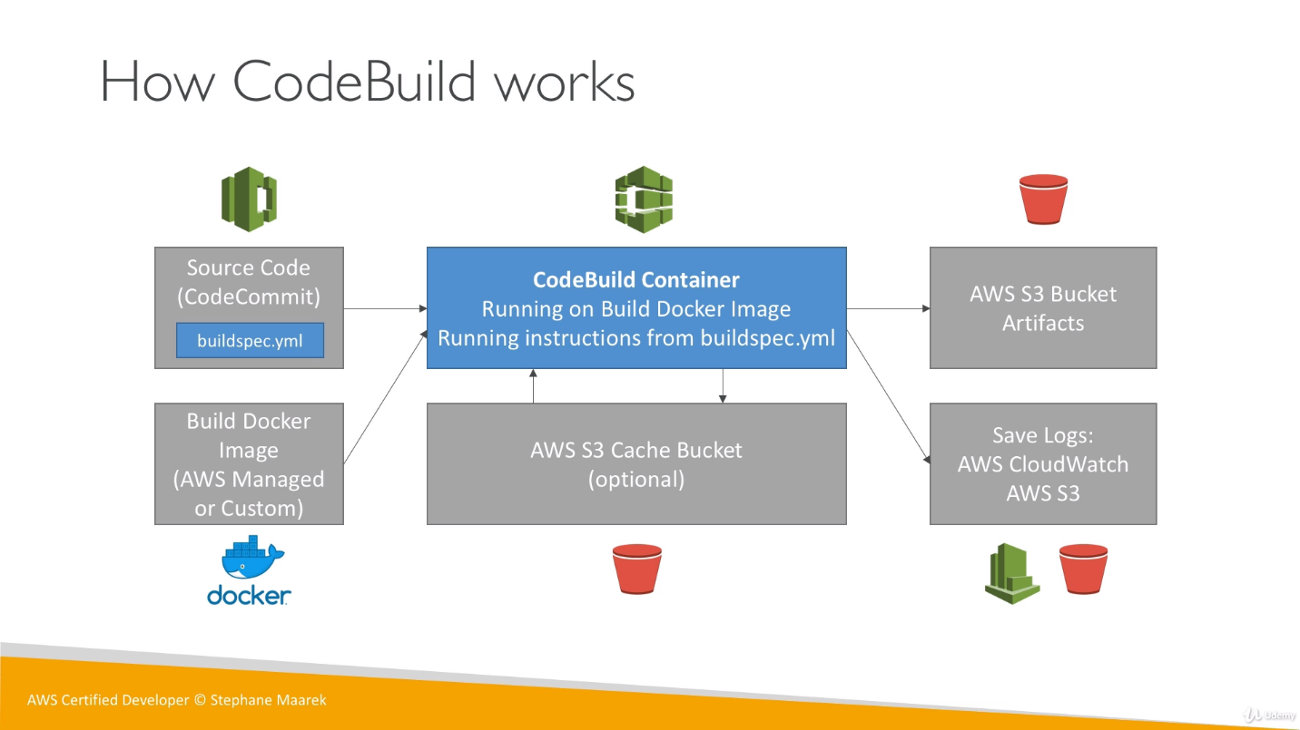

Code can come from any repository or can come as Docker Image to CodeBuild. CodeBuild can have an S3 cache bucket, so if we are doing multiple build then some data can be cached like dependencies, artifacts or other kind of stuff. So, we can pull these stuffs from this cache once the build start so performance will be increased.

Once the code got passed, it will send the output to Amazon S3 bucket (Artifacts bucket). Logs will be saved into the S3 using CloudWatch.

Finally, if all this succeeded then cached files will put back to S3 cache Bucket at last.

**BuildSpec.yml :** We can define some cases in BuilSpec.yml file which will look into all these steps and test them. If all tests got passed, then it will build the code successfully else fail it.

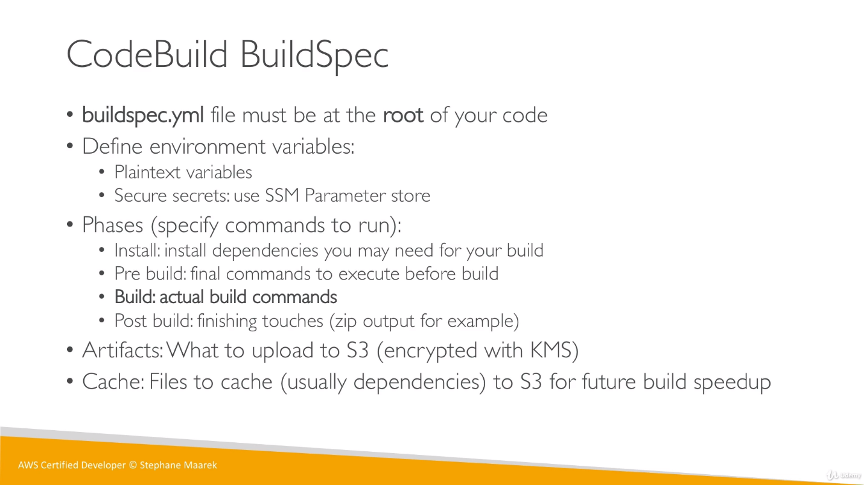

Ex: an example of buildspec.yml file.

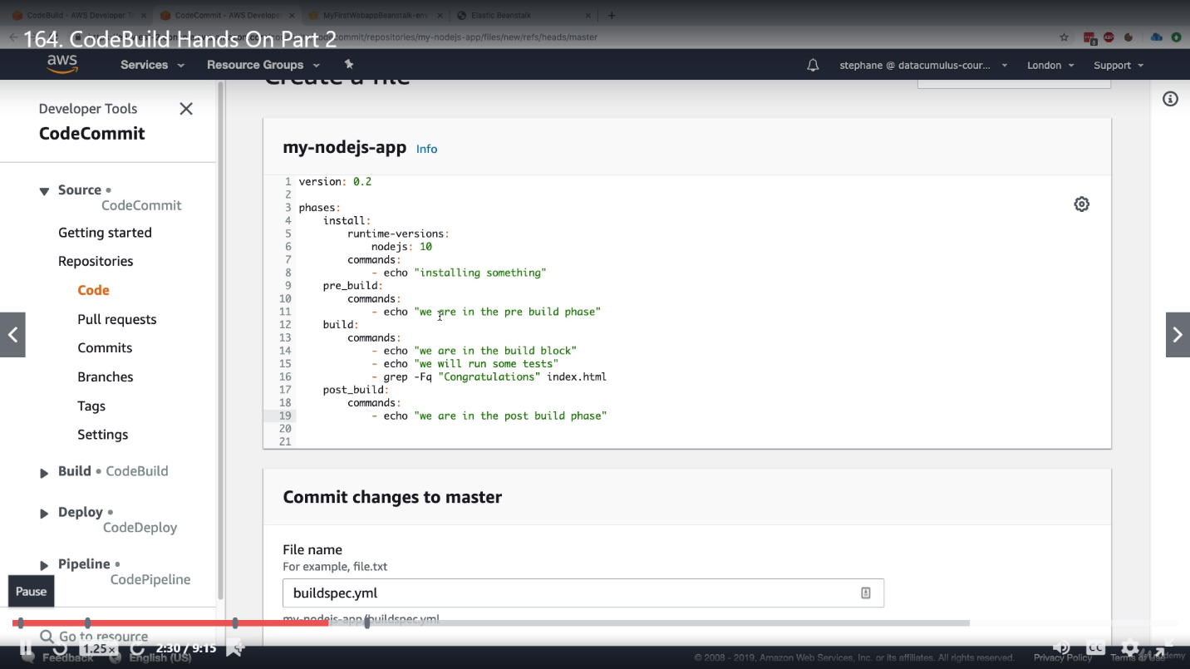

**CodeBuild in VPC:**

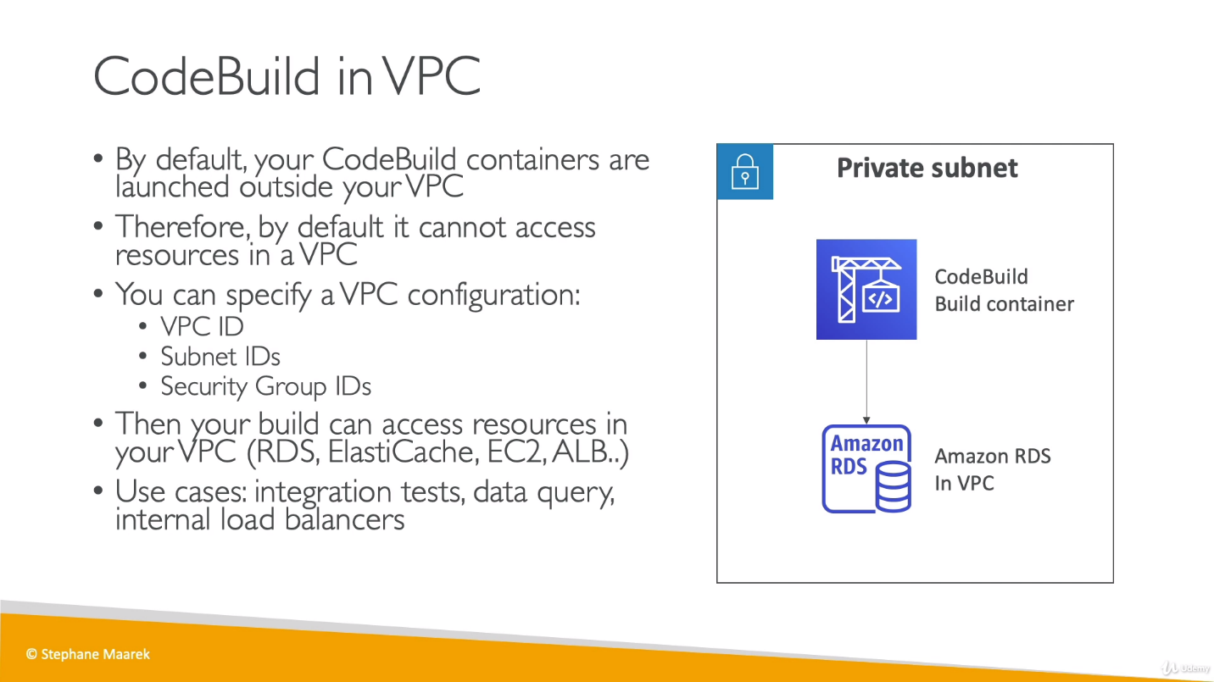

**AWS CodeDeploy:**

EC2 instances for CodeDeploy are managed by us not by Beanstalk.

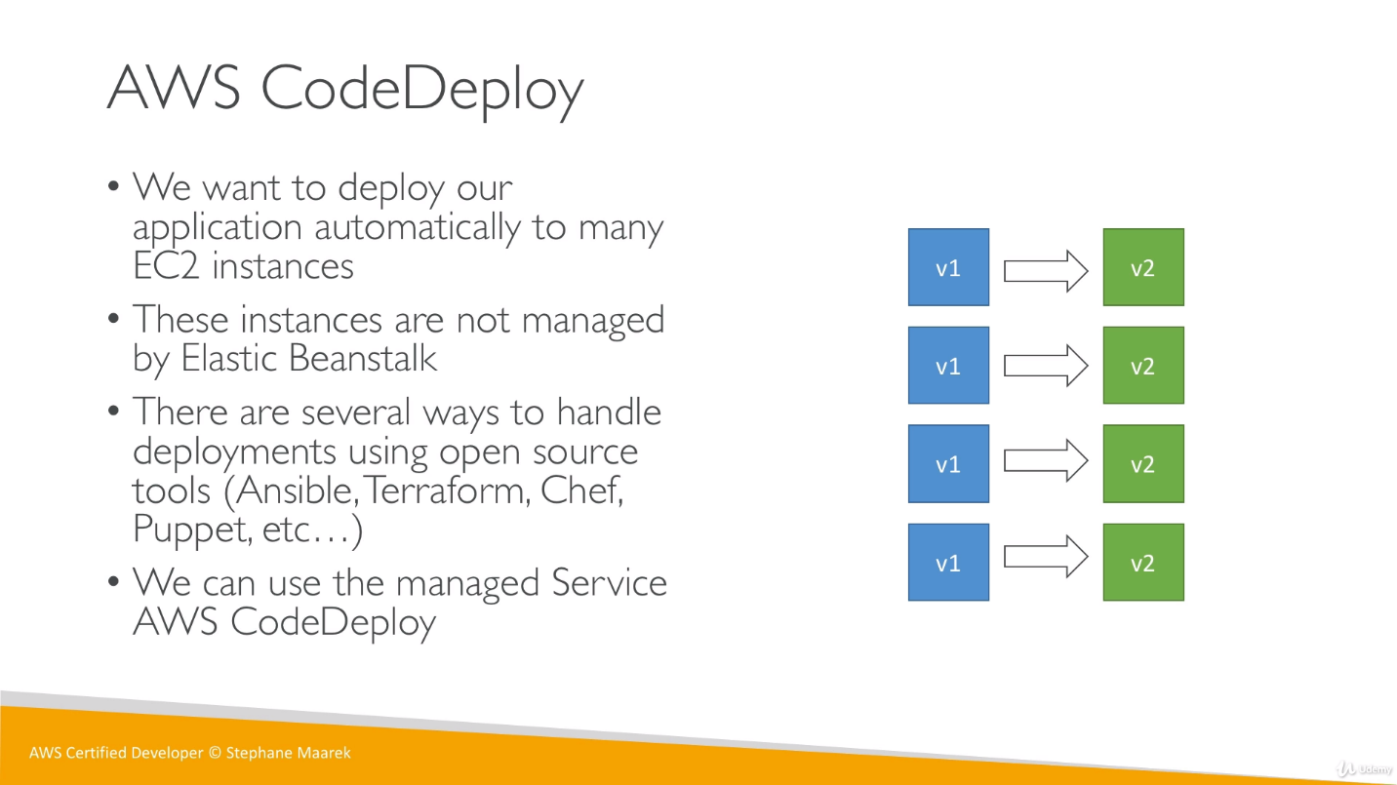

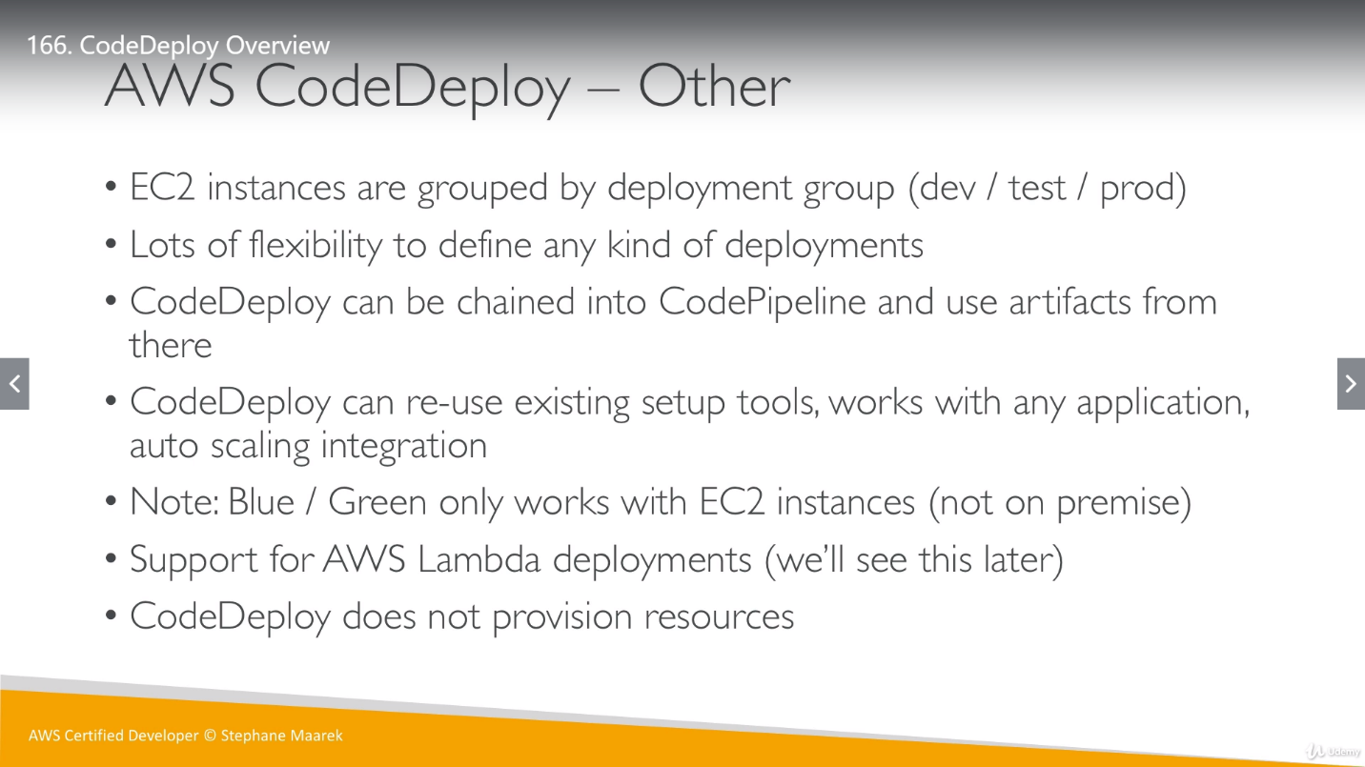

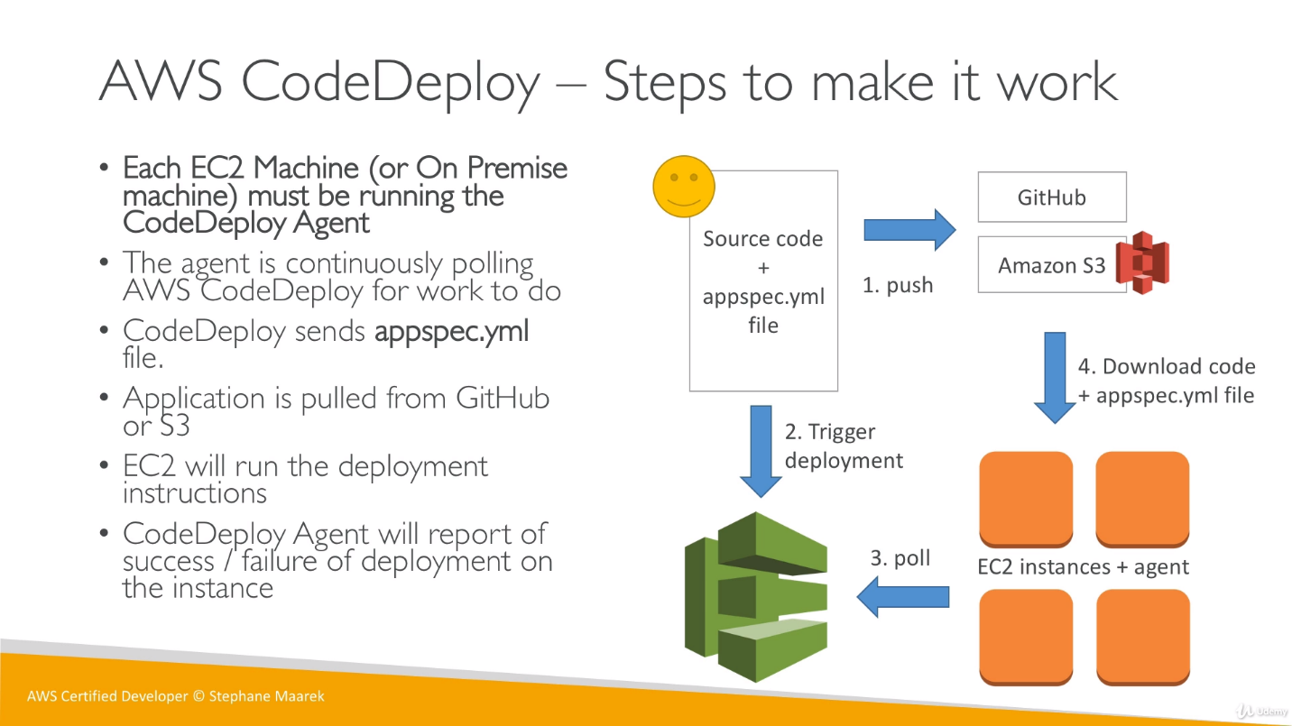

We have appspec.yml (at root of source code) file for CodeDeploy service to work. So we push our code to repository with this file, and then trigger deployment, EC2 instances will come to know that we have trigger deployment, So they will download the code and appspec.yml file onto the EC2 instances and Agent will take care of rest steps based on appspec.yml file to deployment code correctly.

This below slide not to remember, it is just to understand.

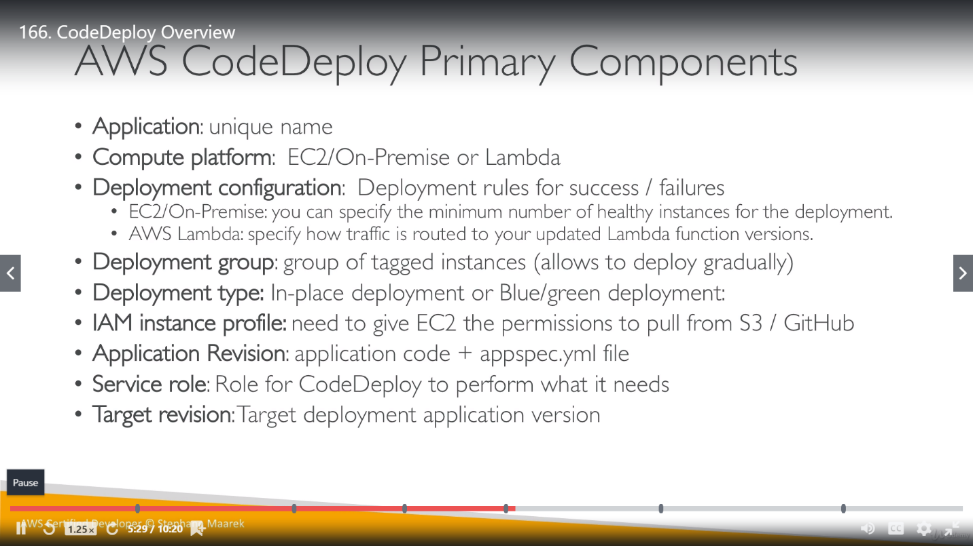

Order of below steps are important and need to remember.

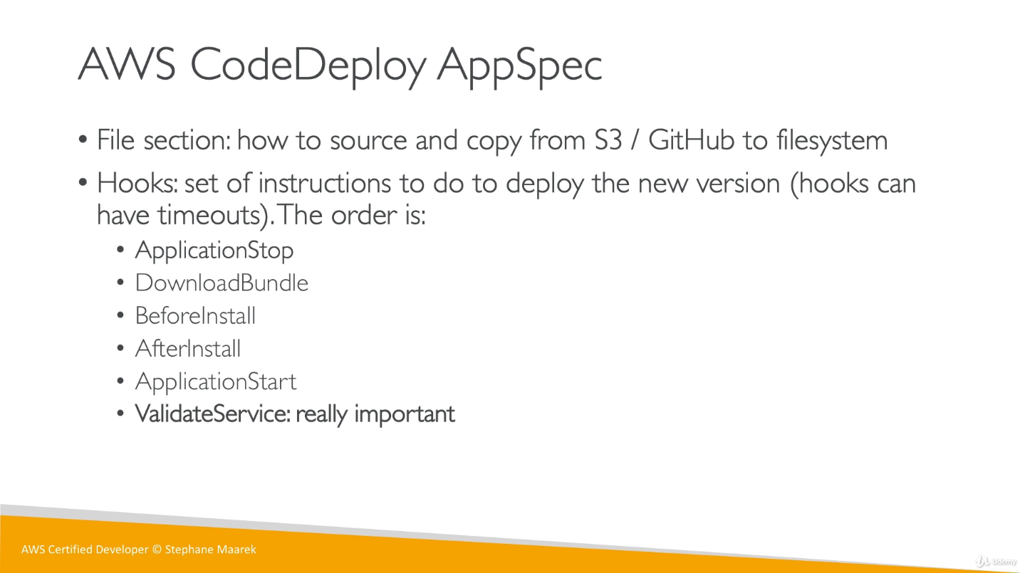

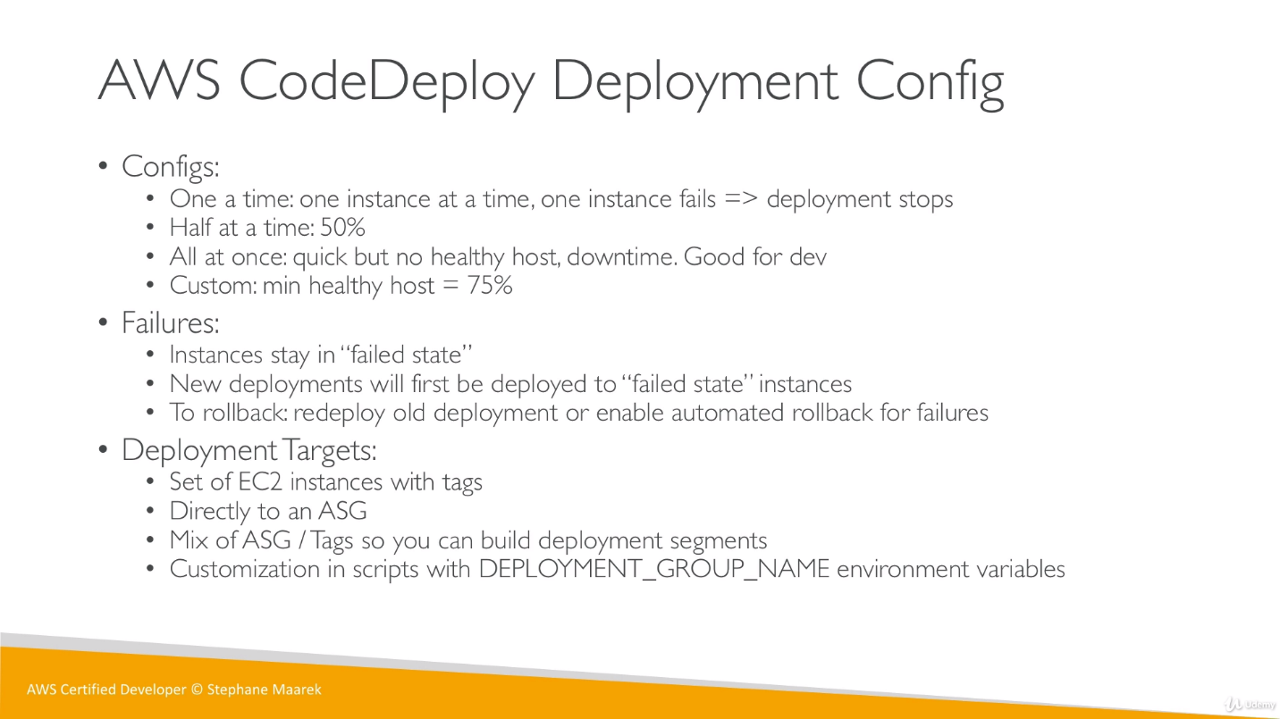 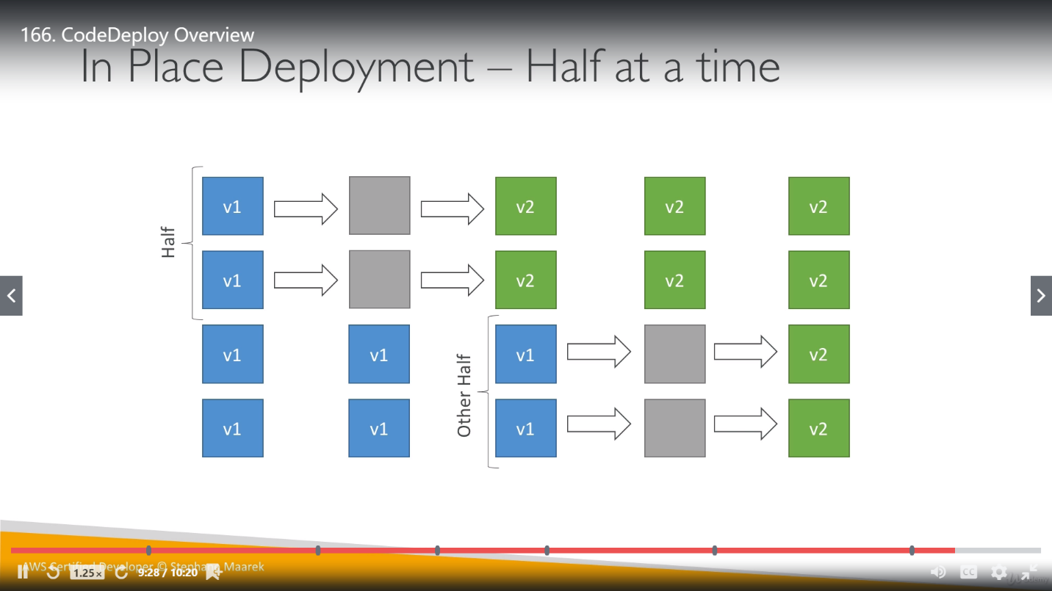 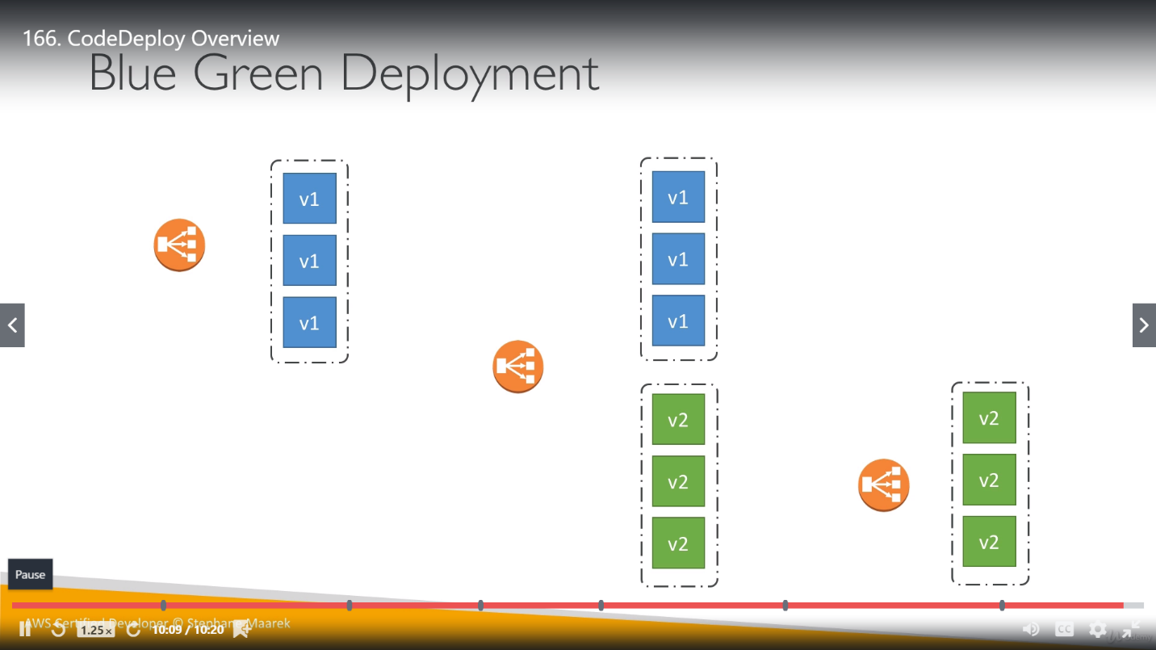

**CodeStar:**

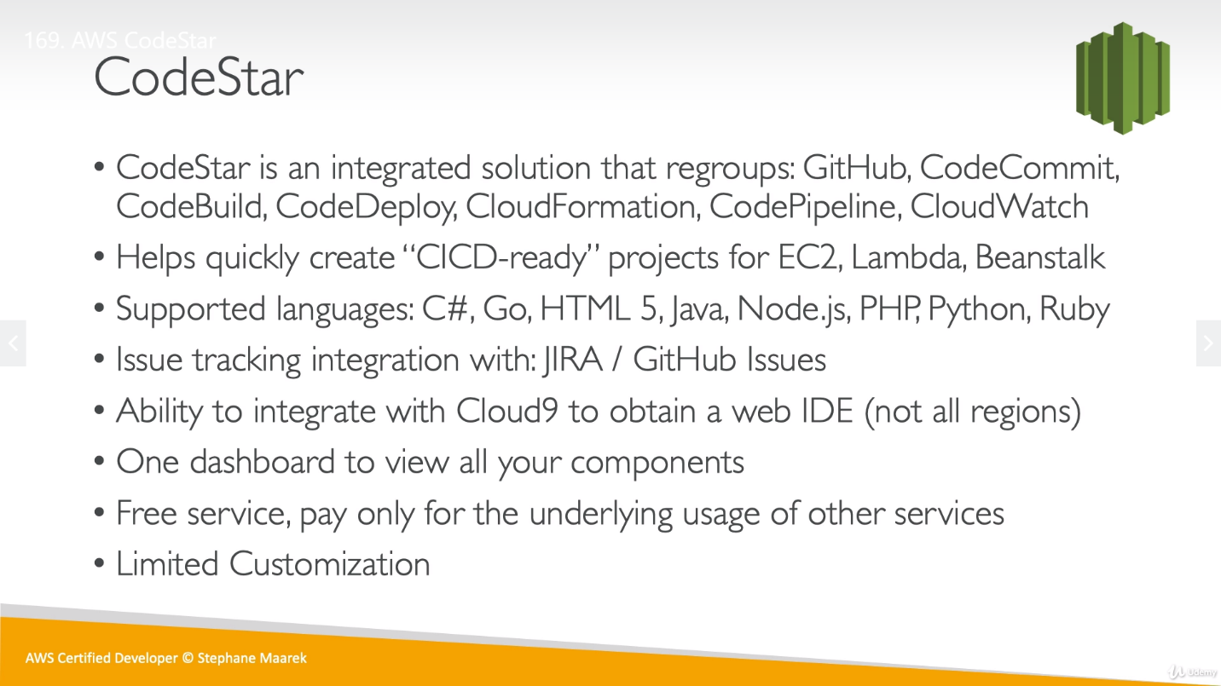

CodeStar does use CodeCommit or Github to store the code. So, difference between CodeStar and CodeCommit is CodeStar uses CodeCommit but also use Github other side CodeCommit doesn’t use CodeStar.

All the things like CI CD pipeline, monitoring etc already configured with CodeStar but we have limited configuration options